|  |  |
| --- | --- |
| **PROJECT TITLE** | **Political Juggernauts : A Quantitative Analysis of Candidates in the 2019 Lok Sabha Elections** |

**PERIYAR UNIVERSITY**

|  |  |
| --- | --- |
| **Team ID: NM 2023TMID22587** | |
| **Student Name** | **Student ID** |
| **ENISHA E** | **9530AC68C148A73B5C54AF667DF345AC** |
| **NIVETHA S** | **59B0746FFF455AC87A4474A867233339** |
| **SARMEEN S** | **211A3BC52F5AFFE9AFC47CFDE34E0A32** |
| **SOWMIYA S** | **CB09855073FE31C8FA745B577116FF35** |

**INCHARGE: Mr. K. CHINNAIYA, M.Sc., M.Ed., M.Phil.,**

**III-BSc Mathematics (2023-2024)**

**DEPARTMENT OF MATHEMATICS**

**101-ARIGNAR ANNA GOVERNMENT ARTS COLLEGE, ATTUR**







**1)INTRODUCTION:**

* **The Lok Sabha is composed of representatives of people chosen by direct election on the basis of Universal Adult Suffrage.**
* **The Constitution of India allows for a maximum of 550 members in the House, with 530 members representing the States and 20 representing the Union Territories.**
* **The 17th Lok Sabha was formed by the members elected in the 2019 Indian general election.**
* **Elections, all across India, were conducted in seven phases from 11 April 2019 to 19 May 2019 by the Election Commission of India.**
* **The Bharatiya Janata Party received 37.36% of the vote, the highest vote share by a political party since the 1989 general election, and won 303 seats, further increasing its substantial majority.**
* **In addition, the BJP-led National Democratic Alliance (NDA) won 353 seats.**

**2) Problem Definition and Design Thinking:**

**2.1) Brainstorming:**

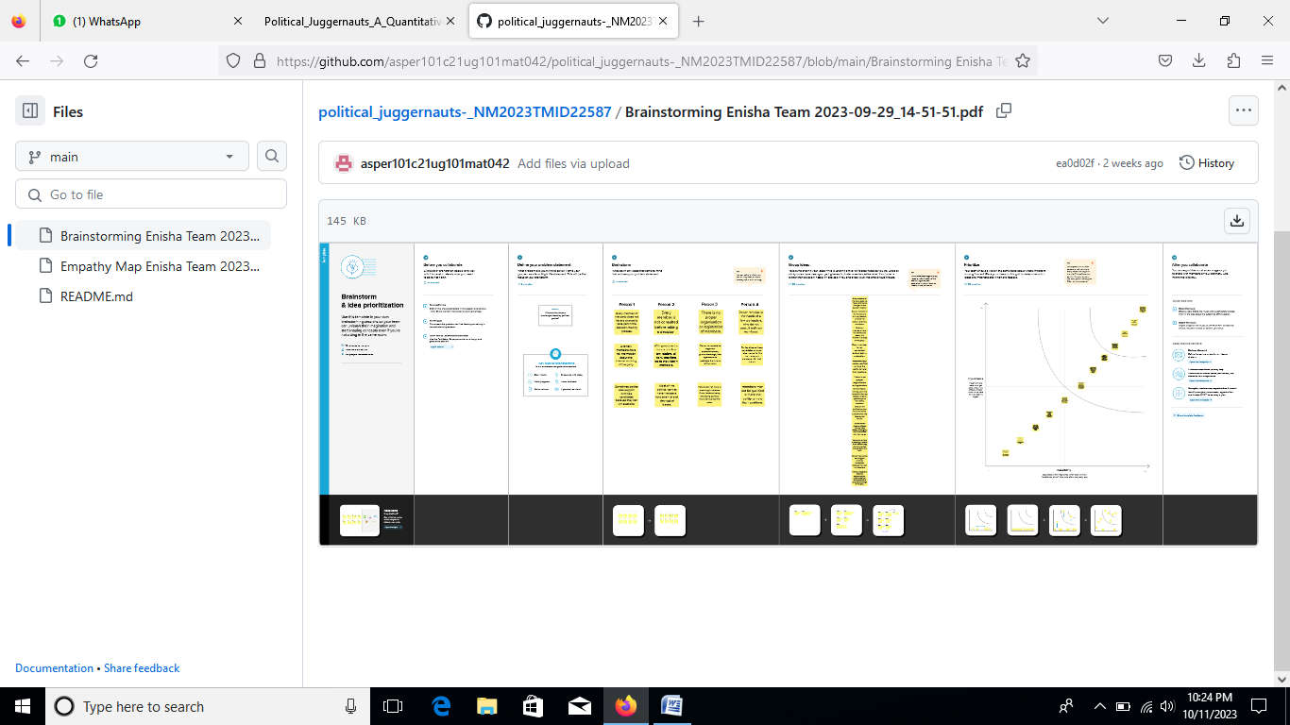

2.2) Empathy map

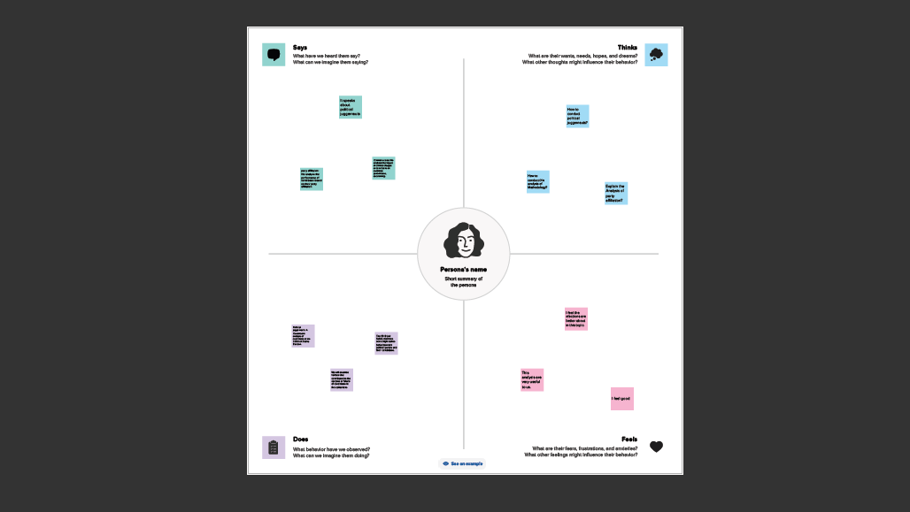

3) Result

3.1) Dashboard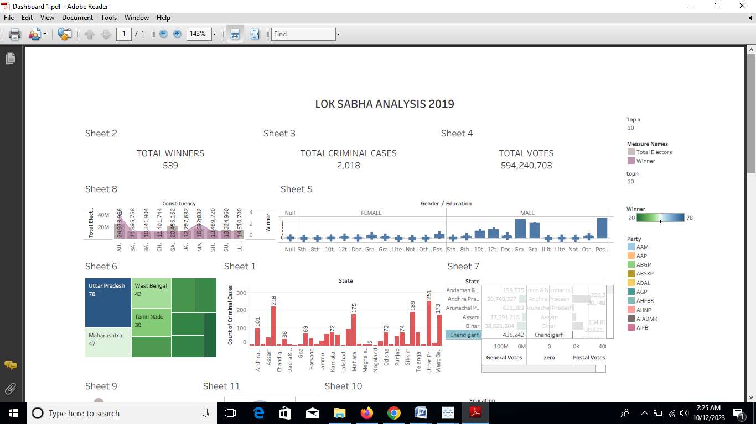

3.2) Story

3.2.1) Story

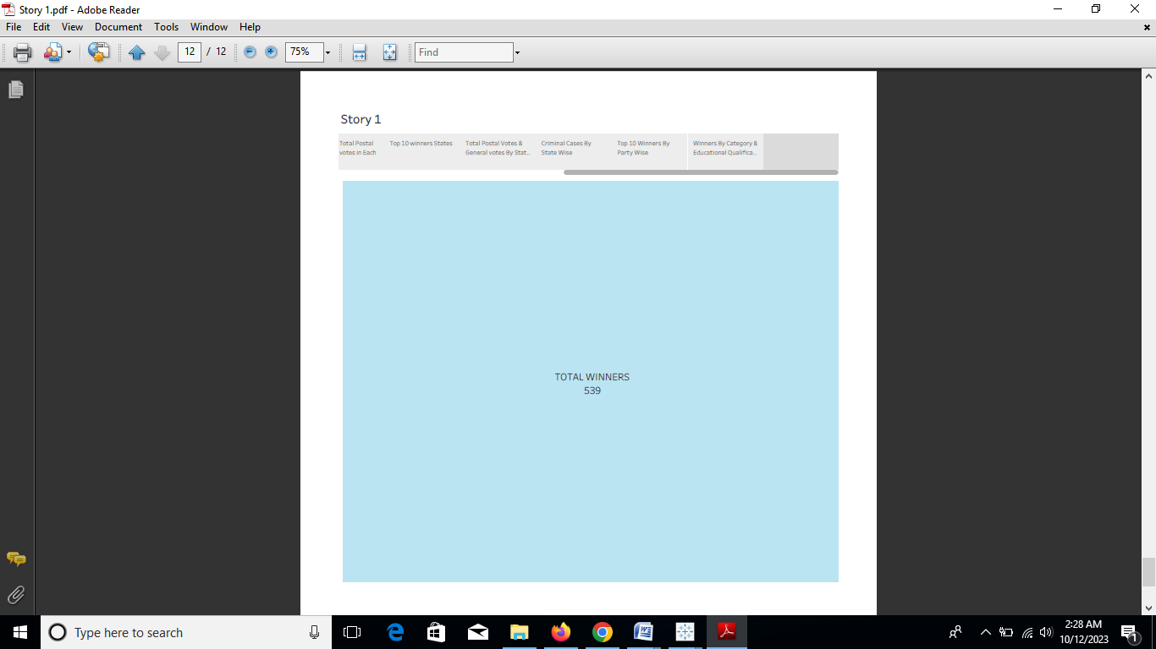

3.2.2) Story

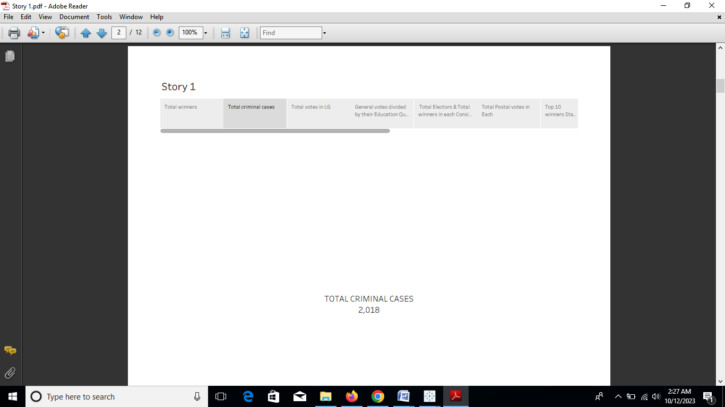

3.2.3) Story

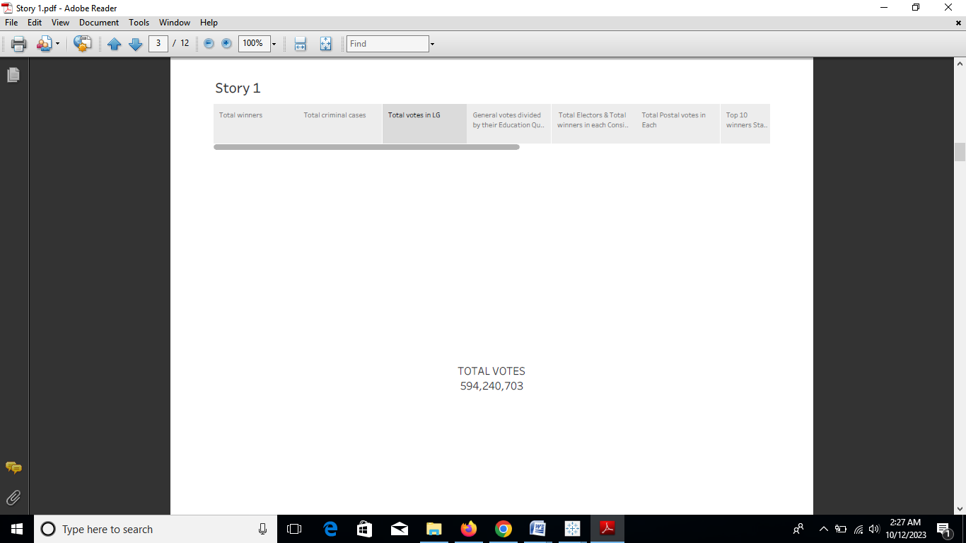

3.2.4) Story

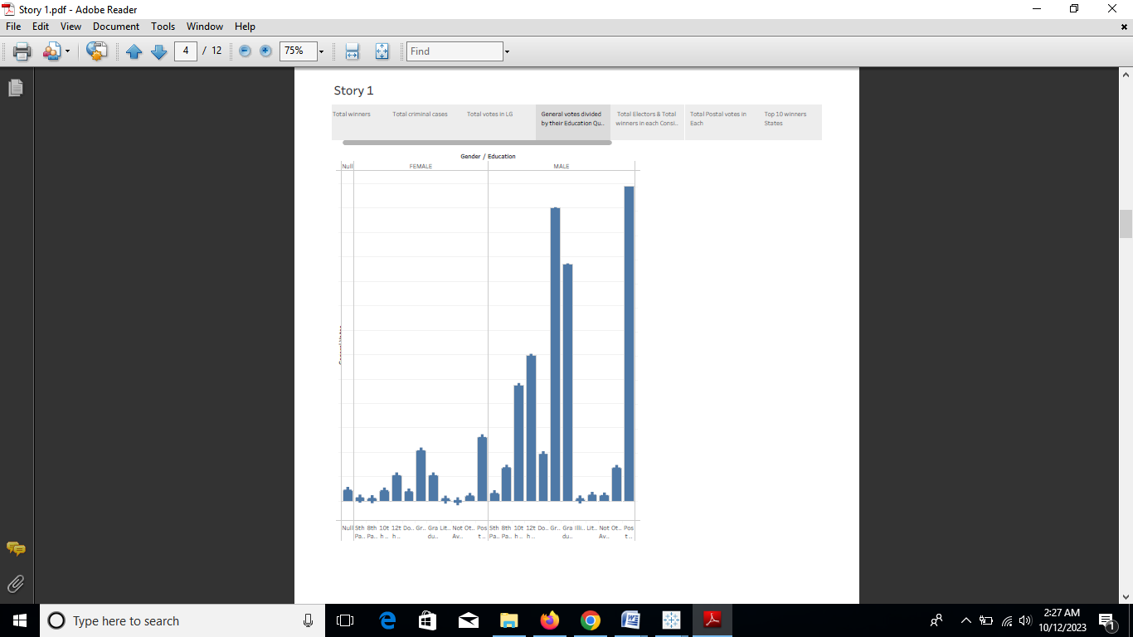

3.2.5) Story

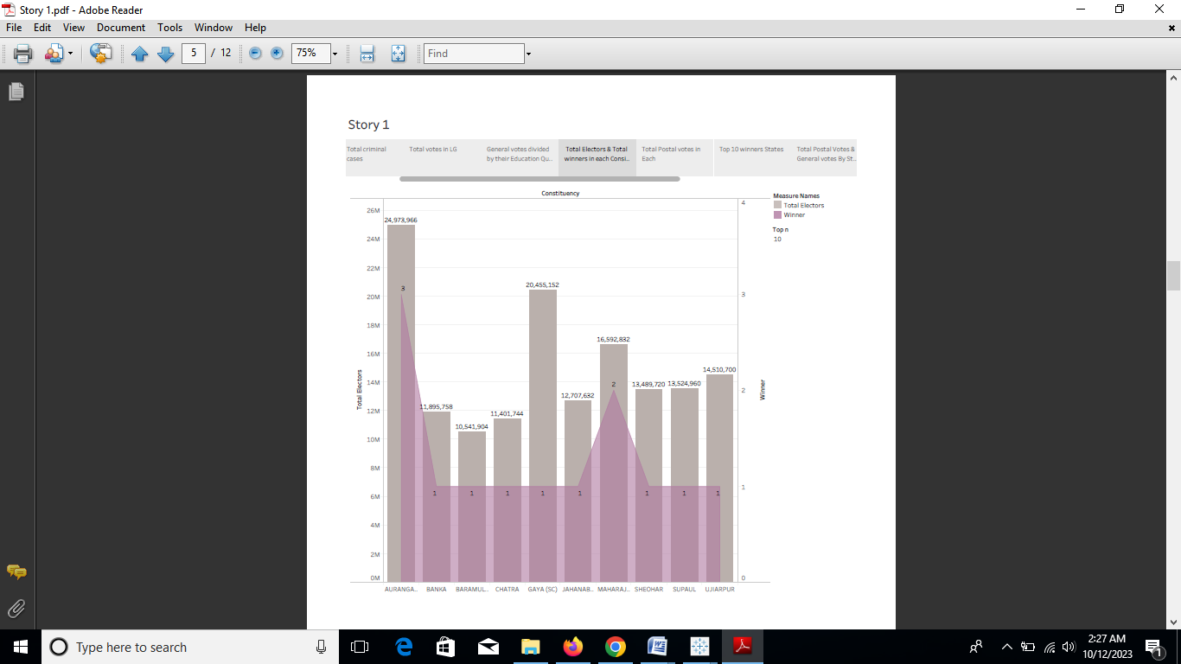

3.2.6) Story

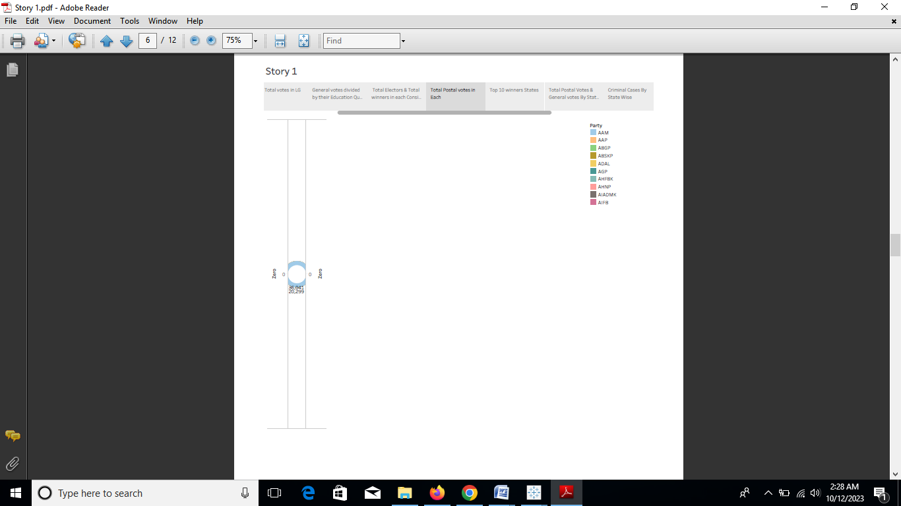

3.2.7) Story

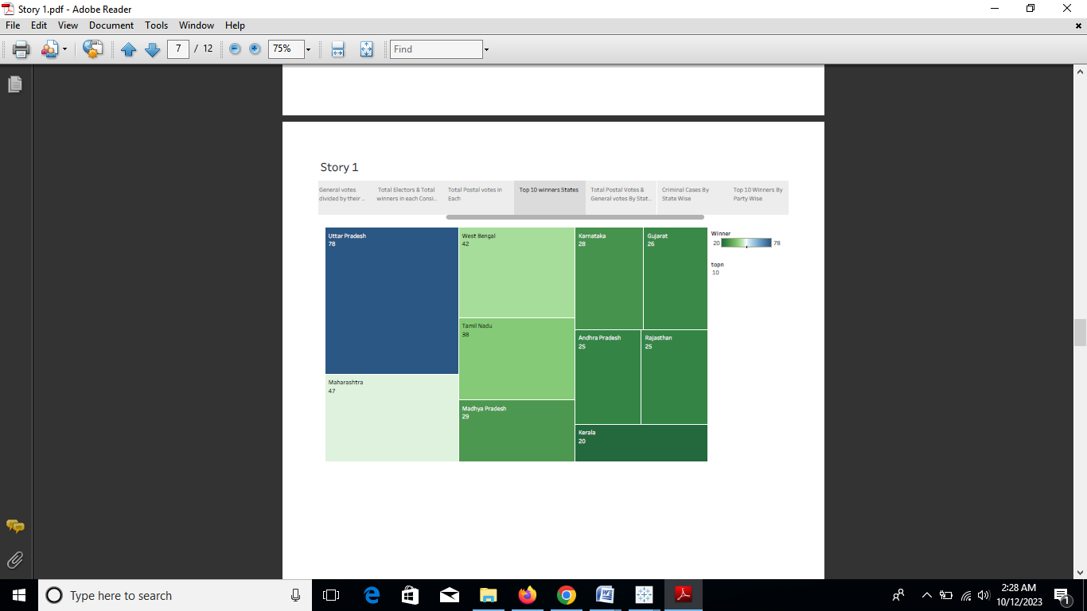

3.2.8) Story

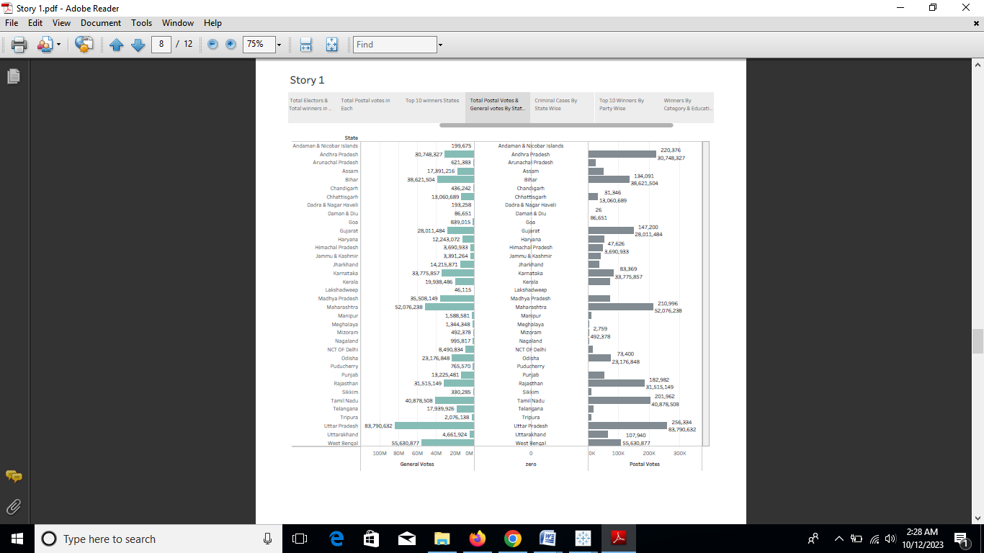

3.2.9) Story

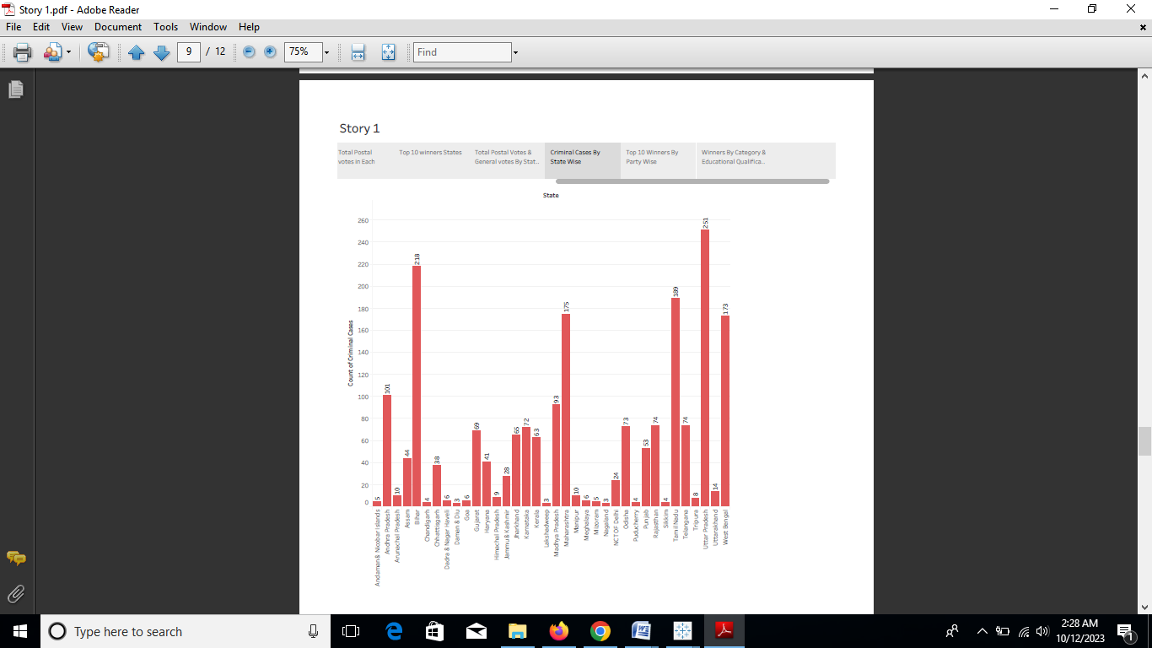

3.2.10) Story

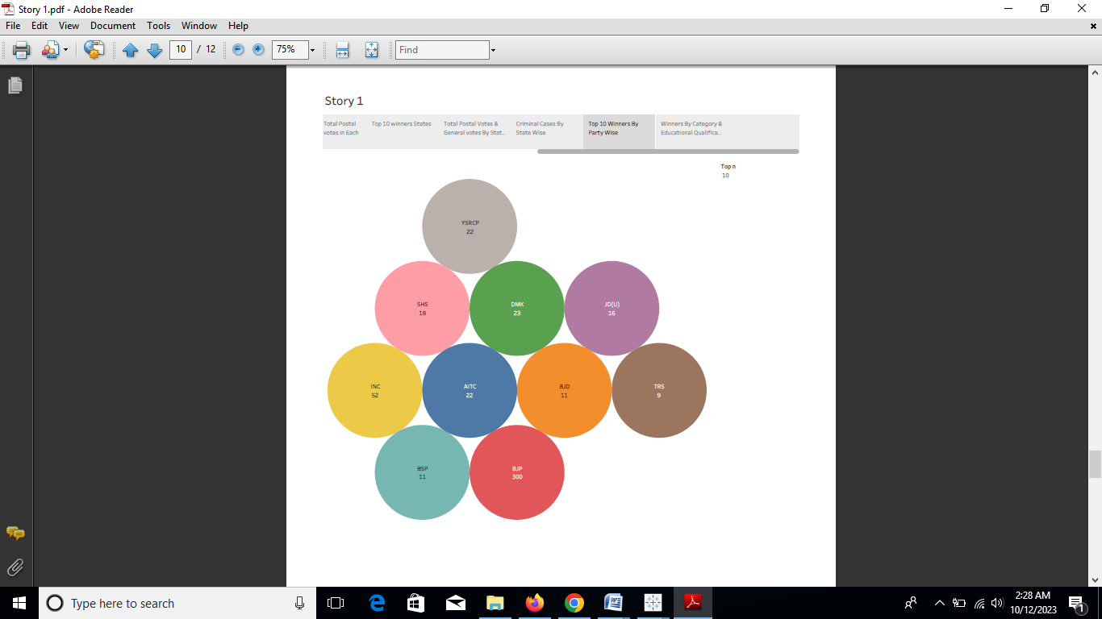

3.2.11) Story

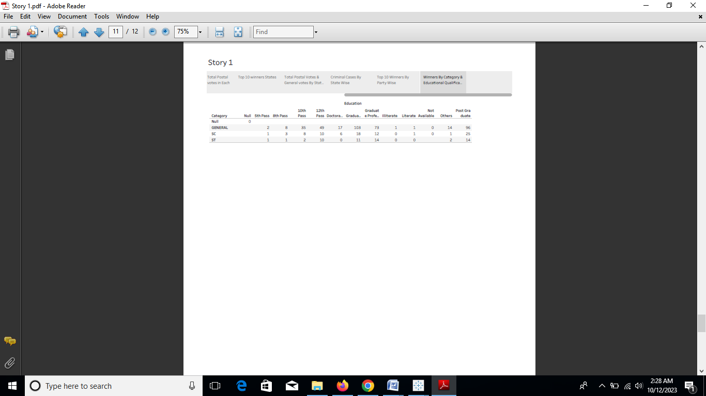

4) Advantages and Disadvantages:

4.1) Advantages

**1. Political parties are able to present political information to the voting population in a manner that is readily understandable.**  
By doing so, there is order in the country through the representation of broad political philosophy of the group. As a result, voters become aware of every party’s stance on certain issues. A good example would be the 2012 Presidential Election between Republican Mitt Romney and Democrat Barack Obama. Each candidate represented major issues of their respective parties to the public.

**2. Political parties provide balance through the accommodation of various interests and opinions.**  
Both political parties are organized groups with differing political views, which make it important for political parties to make decisions that will favor not only few but also all interests and opinions to keep the loyalty of their supporters.

**3. Political parties prevent unexpected shifts in political trends that threaten stability in the government.**  
The US’ two-party system helps promote stability in the government because there will only be two parties sharing power, which can dissolve or change coalitions immediately. Now, if voters disagree on one political issue, they would generally understand that the candidates represent bigger issues that need more attention. This discourages voters from giving up their support for their party. Additionally, elected officials will have time to focus on long-term policies that benefit the public.

**4. Political parties encourage political participation.**   
As a democratic nation, America allows its citizens to freely express their opinions and to support the political party that shares their interest and opinion. Unlike China, the US government encourages the public to participate and cast their votes at the polls. Hence, the public can contribute in making significant changes that will benefit everyone.

4.2) Disadvantages

**1. Political parties might have a selfish propaganda that could hurt national interest.**  
When political parties carry vested interests and vicious propagandas that benefit only a few and are against other parties, it damages the country’s political environment. And when a certain group cares more for its members rather than the entire country, it does not only harm the political atmosphere, but also disturbs the nation’s peace and order.

**2. Political parties could create factionalism.**  
A country with a party system could render political life artificial. It could create animosity between parties, encourage jealousy and develop occasional riots and insurrection. As a result, the public is forced to form factions because they could not agree on certain levels.

**3. Political parties could ruin individuality.**  
There may be parties that expect or force the people support and share their views blindly. They might not allow its own people to criticize their shortcomings. In short, the people may not be allowed to form their individual opinions on certain issues because they are expected to follow what their party is telling them.

**4. Political parties could encourage corruption.**  
There will be parties that distribute money to the electorate to secure votes for their candidates. Aside from that, their candidates may be making promises only to persuade the voting population into electing them. But once they are elected into office, they might never deliver to their promises. They might also place those who supported them in higher positions in exchange for their votes.

**5) Application:**

* A major benefit of using quantitative data is **its objectivity**. It relies on concrete numbers and fewer variables.
* This can help to remove biases from the research and make the findings more accurate. Another benefit is that it is often easier to obtain large sample sizes.
* Quantitative analysis is used by governments, investors, and businesses (in areas such as finance, project management, production planning, and marketing) **to study a certain situation or event, measure it, predict outcomes, and thus help in decision-making**.
* Top of Form
* Quantitative data analysis has two branches: **descriptive statistics and inferential statistics**.
* Descriptive statistics provide a snapshot of the data's features by calculating measures like mean, median, and mode. Inferential statistics, as the name implies, involves making inferences about what the data means.

6) Conclusion:

* The discussion so far can be summarized in terms of the links between the flow of communications and the characteristics of the political system and processes.
* One model suggests that a link exists between a political system's openness to bargaining and the free flow of information, and its ability to engage in a process of decision making.
* The opposite model describes a closed political system, in which demands are privatized, information is channeled through intelligence-gathering agencies, and the system's capability for decision making is impaired, although the capability for policy implementation is increased.
* The first model was said to be conducive to the institutionalization of technical decision making bodies; in the second model, the technical bodies tend to become technocratic.
* It is therefore necessary to conclude with a brief discussion of the assumptions implied in these models.  
    
  The crucial point seems to be the difference between intelligence and information. The expression intelligence," as used in this context, has less the broad meaning of "control of the environment" than the more specific sense of "data gathering" of a specific type: namely, the data necessary for developing the means to reach a given end. Once the goal is defined, data gathering is essentially a technical task.
* The definition of a task as "technical" implies that the circle of participants in the decision is frozen, the hierarchy of values is established, and value differences are assumed not to exist. There are two ways of defining a situation as technical, by institutionalization or by superordination.
* In the first case, there is both developed competence and social legitimation of the decision- making body; in the second, the lack of legitimacy changes the technical into the technocratic.
* Technocracy is thus sub- politicization - a process by which the political content of politics is concealed through its transformation into a simple operational decision.

7) HTML CODE:

<div class='tableauPlaceholder' id='viz1697085088750' style='position: relative'><noscript><a href='#'><img alt='LOK SABHA ANALYSIS 2019 ' src='https:&#47;&#47;public.tableau.com&#47;static&#47;images&#47;Lo&#47;LokSabhaAnalysis2019StoryBoard_16970141508930&#47;Dashboard1&#47;1_rss.png' style='border: none' /></a></noscript><object class='tableauViz' style='display:none;'><param name='host_url' value='https%3A%2F%2Fpublic.tableau.com%2F' /> <param name='embed_code_version' value='3' /> <param name='site_root' value='' /><param name='name' value='LokSabhaAnalysis2019StoryBoard_16970141508930&#47;Dashboard1' /><param name='tabs' value='no' /><param name='toolbar' value='yes' /><param name='static_image' value='https:&#47;&#47;public.tableau.com&#47;static&#47;images&#47;Lo&#47;LokSabhaAnalysis2019StoryBoard_16970141508930&#47;Dashboard1&#47;1.png' /> <param name='animate_transition' value='yes' /><param name='display_static_image' value='yes' /><param name='display_spinner' value='yes' /><param name='display_overlay' value='yes' /><param name='display_count' value='yes' /><param name='language' value='en-US' /><param name='filter' value='publish=yes' /></object></div> <script type='text/javascript'> var divElement = document.getElementById('viz1697085088750'); var vizElement = divElement.getElementsByTagName('object')[0]; vizElement.style.minWidth='1400px';vizElement.style.maxWidth='1500px';vizElement.style.width='100%';vizElement.style.minHeight='827px';vizElement.style.maxHeight='1227px';vizElement.style.height=(divElement.offsetWidth*0.75)+'px'; var scriptElement = document.createElement('script'); scriptElement.src = 'https://public.tableau.com/javascripts/api/viz_v1.js'; vizElement.parentNode.insertBefore(scriptElement, vizElement); </script>

<div class='tableauPlaceholder' id='viz1697085698252' style='position: relative'><noscript><a href='#'><img alt='Story 1 ' src='https:&#47;&#47;public.tableau.com&#47;static&#47;images&#47;Lo&#47;LokSabhaAnalysis2019StoryBoard_16970141508930&#47;Story1&#47;1_rss.png' style='border: none' /></a></noscript><object class='tableauViz' style='display:none;'><param name='host_url' value='https%3A%2F%2Fpublic.tableau.com%2F' /> <param name='embed_code_version' value='3' /> <param name='site_root' value='' /><param name='name' value='LokSabhaAnalysis2019StoryBoard_16970141508930&#47;Story1' /><param name='tabs' value='no' /><param name='toolbar' value='yes' /><param name='static_image' value='https:&#47;&#47;public.tableau.com&#47;static&#47;images&#47;Lo&#47;LokSabhaAnalysis2019StoryBoard_16970141508930&#47;Story1&#47;1.png' /> <param name='animate_transition' value='yes' /><param name='display_static_image' value='yes' /><param name='display_spinner' value='yes' /><param name='display_overlay' value='yes' /><param name='display_count' value='yes' /><param name='language' value='en-US' /><param name='filter' value='publish=yes' /></object></div> <script type='text/javascript'> var divElement = document.getElementById('viz1697085698252'); var vizElement = divElement.getElementsByTagName('object')[0]; vizElement.style.width='1016px';vizElement.style.height='991px'; var scriptElement = document.createElement('script'); scriptElement.src = 'https://public.tableau.com/javascripts/api/viz_v1.js'; vizElement.parentNode.insertBefore(scriptElement, vizElement); </script>

* Bottom of Form
* Top of Form
* Bottom of Form
* Top of Form
* Bottom of Form